Math 740/840 Homework Assignment #3 Fall 2019

Due 10/30/2019

1. (15 pts.) Engineers are developing a new paint formulation for automobile applications. The new formulation has strict performance requirements and the engineers what the cured paint surface to have a **Knoop Hardness** > 25 and a **Percent Solids** < 30; these are the two primary responses in the experiment. There are three components in the formulation that are manipulated in an experiment and each has the following constraints on the allowable range used in the experiment.  
     
   A: **Monomer** 0.05 to 0.25  
   B: **Crosslinker** 0.25 to 0.40  
   C: **Resin** 0.50 to 0.70  
     
   note that A + B + C =1.0 is a requirement for the settings on each trial. Use the dataset **Paint Formulation Experiment.JMP** to answer the following questions.  
   1. **What type of experimental design has been employed by the engineers? Be specific.**

It is a mixture design with constraints on the lower and upper bounds. It will make a triangle of possibilities as there are three components.

* 1. **For the response Y1-Hardness use the Fit Model platform to fit a special cubic model to the data. You are shown how to do this in the Mixture Design 1 notes. Focus only on the Y1 response at this point. Once you fit the model, do not attempt to simplify the model by removing terms. What terms appear most dominant to the Harness response? Be sure to include the Parameter Estimates table screenshot with your answer. Finally, save the estimated prediction equation to the data table. To do this click on the main report (red arrow) at the top of the window to the left of Response, next click on the Save Columns submenu and select Prediction Formula. A column with the prediction formula now appears in your data table.**

The Resin effect seems to be the most dominant on the harness response value followed by the monomer value.  
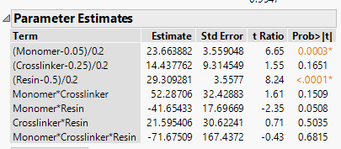

* 1. **Repeat part b, but this time do the analysis for the Y2-%Solids response. Once you complete parts b and c you should have two formula columns in your data table; one for each of the two responses.**The resin effect is again the most dominant to the harness response value followed closely by the monomer effect.  
     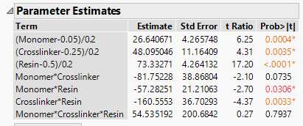
  2. **We now ready to find an optimum formulation that meets the specification requirements for both responses. To do this, first go to the Graph menu and select Profiler (Graph 🡪 Profiler). In the Profiler launch dialog window place both formula columns in the Y columns box and click OK to open the Profiler report. Once in the report window select Maximize Desirability from the Prediction Profiler report. Note, I have already specified the desirability settings for both response as Column Properties, so the Desirability Functions automatically appear in Prediction Profiler display. Be certain to include a screenshot of your optimized settings for the three formulation components and the predicted responses. Does your optimized formulation meet the constraints on each of the 3 components? Do the predicted values for each of the two responses meet the specifications for the paint formulation? Explain.**

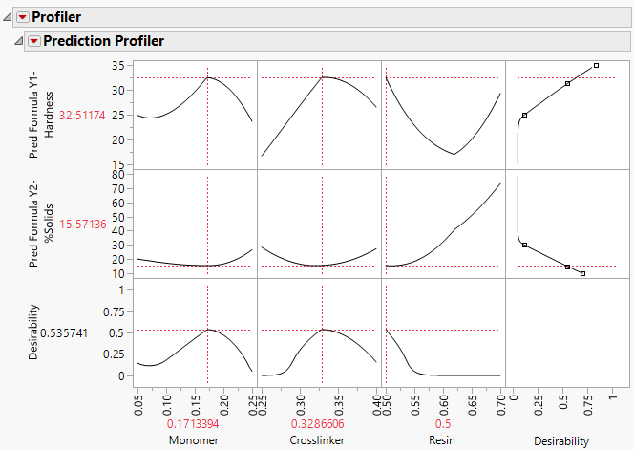The wanted mixtures are all within the limits constrained as they were defined in the analysis. They both meet the requirements for the pain formulation in hardness and solids as they are above 25 and less then 30, respectively. If they weren’t, we would need to reconsider the design and constrains to see if that could be met!

* 1. **Finally, using your Prediction Profiler report, do the relationships between each of the two responses and three formulation components appear to be the same or different? You can answer this qualitatively by simply looking at the response traces or profiles for each of the components for each of the response.**

They are different. For hardness, the monomer and crosslinker are negative quadratic parabolas, while in Solids they are positive and have a smaller ‘a’ value. They do technically exhibit the same shape, though. The resin component is very different for both as it is a positive quadratic for the hardness, but more of a linear line for Solids.

1. **(15 pts) Material scientists are studying a process to make ceramic parts. They are independently varying 3 factors at two levels each: %Silicon in the ceramic, %Calcium in the ceramic, and two Cooling Processes. The scientists elected to perform three replicates of the experiment which requires 24 total runs. The firing furnaces available to the scientists can only accommodate a set of 4 parts in a single cycle. So, in order to perform all of the runs simultaneously a set of 6 furnaces were required (4 parts per furnace); the furnaces are the same type, but scientists are concerned that some differences could exist among the furnaces. Use the data set Ceramic Sintering.JMP to answer the following questions. Hint: you should review the Soda Fill case study starting on page 20 of the Incomplete Blocking notes before attempting a solution to this problem.**
   1. **What is the blocking factor?**The blocking factor are the furnaces
   2. **What interaction is used to create blocks 1 and 2; blocks 3 and 4; blocks 5 and 6?**

Blocks 1 and 2 were made from the interaction between percent calcium and cooling, process 1

Blocks 3 and 4 were made from the interaction between percent silicon and cooling, process 1

Blocks 5 and 6 were made from the interaction between percent silicon/calcium and cooling, process 1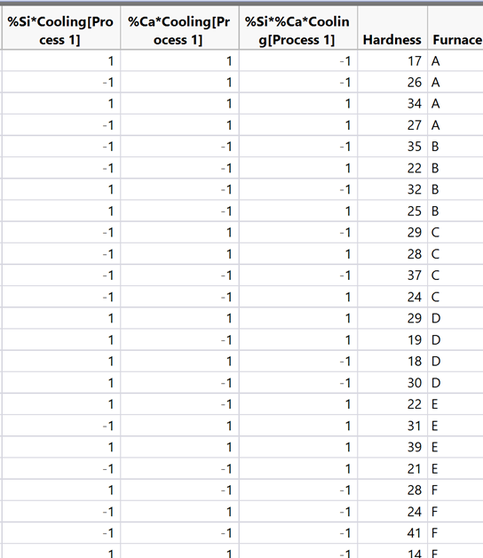

* 1. **What is the effect of the blocking scheme on the standard errors of the different effect estimates in the full model?**The blocking scheme should lower the errors of the different effects estimates on the hardness.
  2. **Find the best model for hardness, using the Fit Model platform in JMP. Be certain to include a screenshot of the Parameter Estimates table for your final model.  
     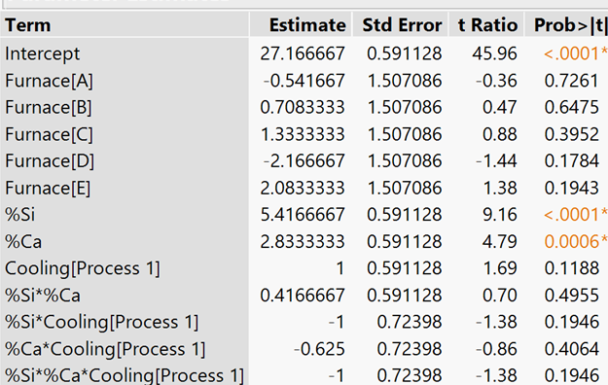**
  3. **Does the blocking factor appear to be needed in the model (use a relative efficiency argument, discussed in the Blocking Designs for One Factor notes starting on slide 19)? Explain.**When the blocking factor has a number less then 1, then it is something that does not significantly effect the model. Because it is printing near 1, that leads us to prove that it does not effect the model significantly!

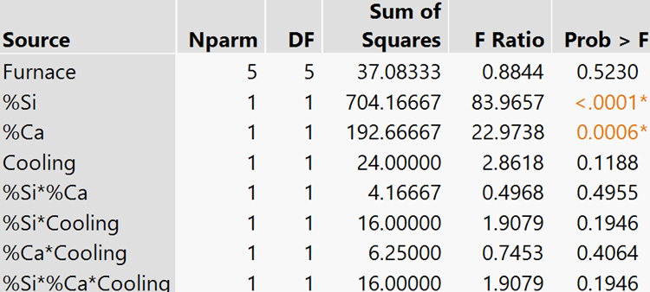

* 1. **Based upon your model, use Desirability Functions in the Prediction Profiler to determine the settings of the experimental factors that would you recommend to the Engineer in order to achieve maximum hardness? Again, be certain to include a screenshot of your Profiler showing the optimized settings.**

So, the affect from the furnace factor, and the percent silicon/calcium and the silicon/calcium/cooling were all removed as the they did not play a significant role on the outcome of the model. When those were removed, I could focus on the factors that affect the system. Then, a desirably function was placed to determine that the setting below are the most optimal given the constraints:

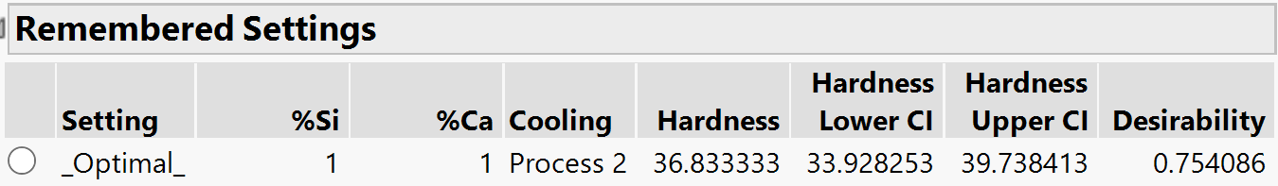

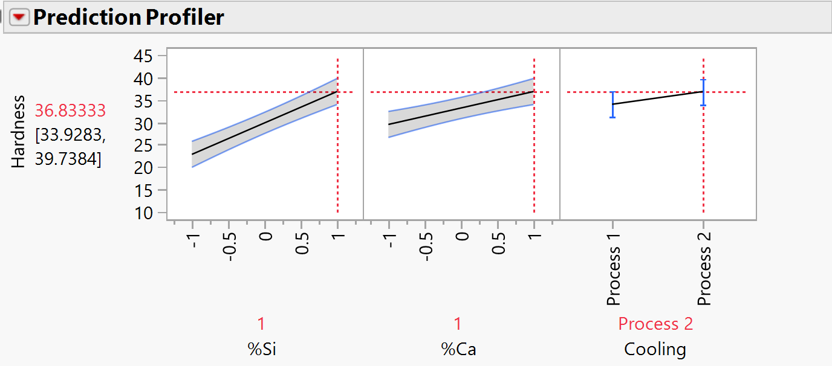

Which means that 1/1% calcium and silicon and the cooling process 2 yield the most desirable result! This whole problem was difficult and had to guess on a few of the steps!